**VAE Model Summary for encoder and decoder**

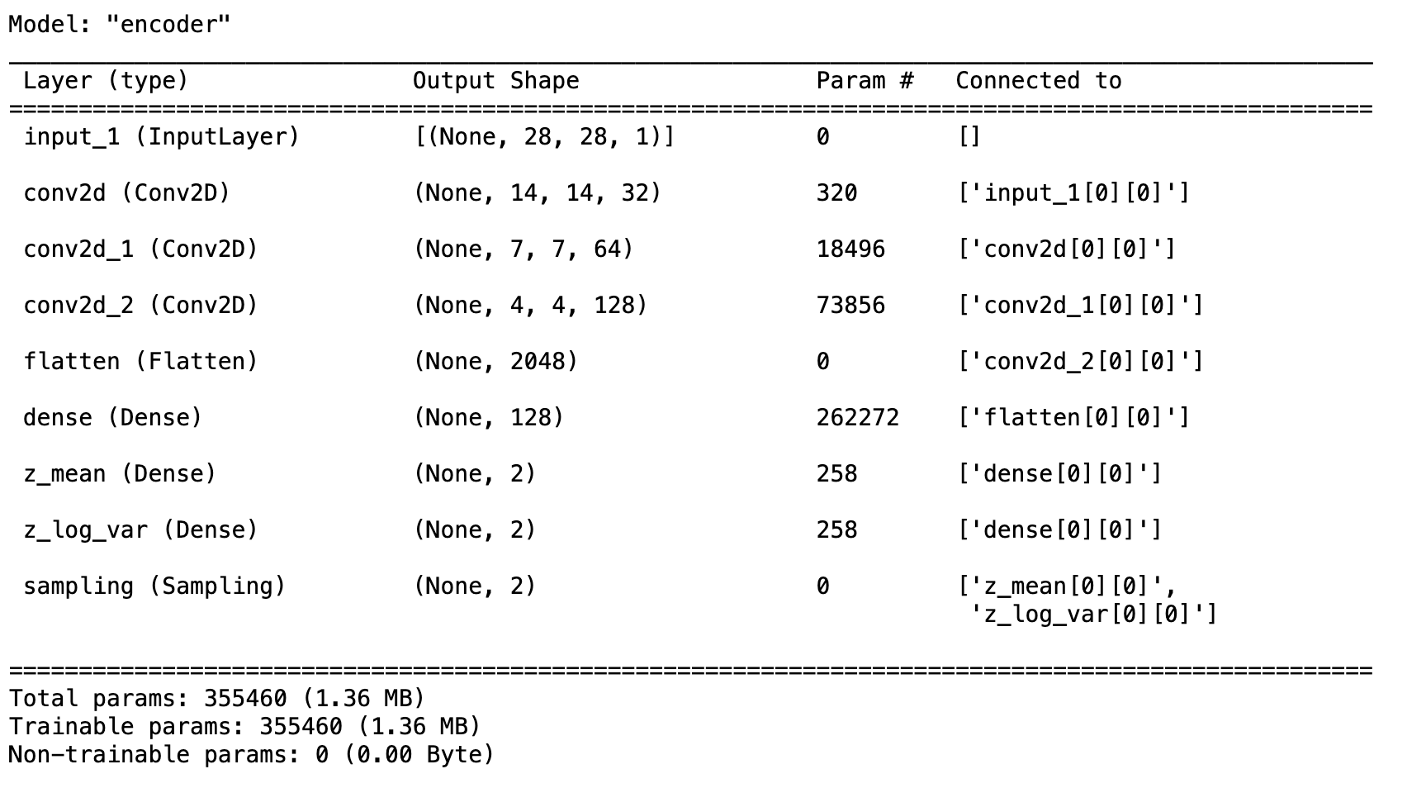

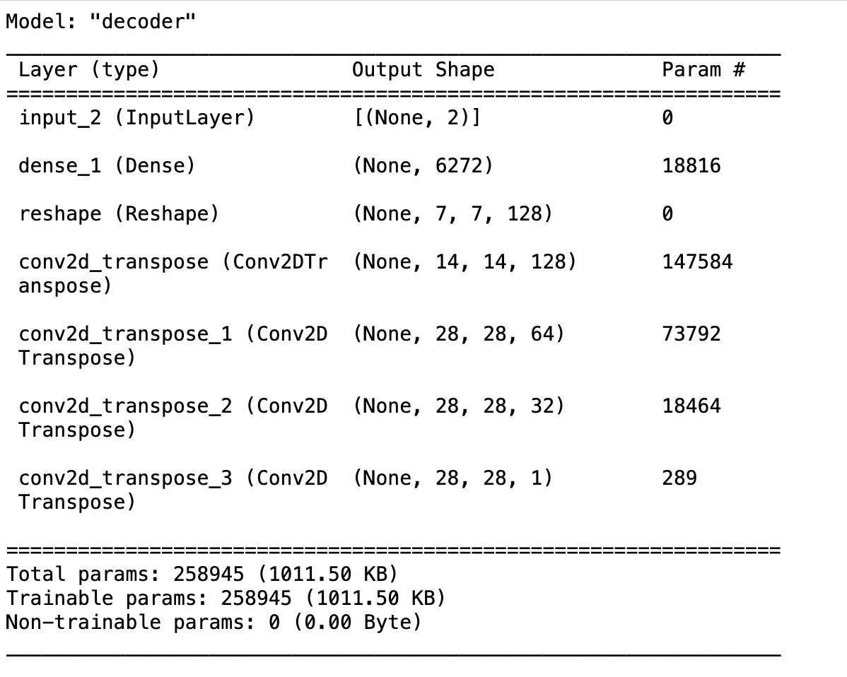

|  |  |
| --- | --- |
| **Hyperparameter** | **Value** |
| Activation Function | ReLU (Rectified Linear Unit) |
| Weight Initializer | Glorot_uniform |
| Number of Hidden Layers | Encoder: 3 , Decoder: 4 |
| Neurons in Hidden Layers | Encoder: [32, 64, 128], Decoder: [6272, 128, 64, 32, 1] |
| Loss function | Binary Crossentropy (BCE) for Reconstruction Loss, KL Divergence for KL Loss |
| Optimizer | Adam |
| Number of Epochs | 30 |
| Batch Size | 128 |
| Evaluation Metric | BCE and KL Loss |
| Encoder Layers | input_1, conv2d, conv2d_1, conv2d_2, flatten, dense, z_mean, z_log_var, sampling |
| Decoder Layers | input_2, dense_1, reshape, conv2d_transpose, conv2d_transpose_1, conv2d_transpose_2, conv2d_transpose_3 |

**Problem 2:**

TF-IDF + GaussianNB Word2Vec (CBoW) + GaussianNB Glove + GaussianNB

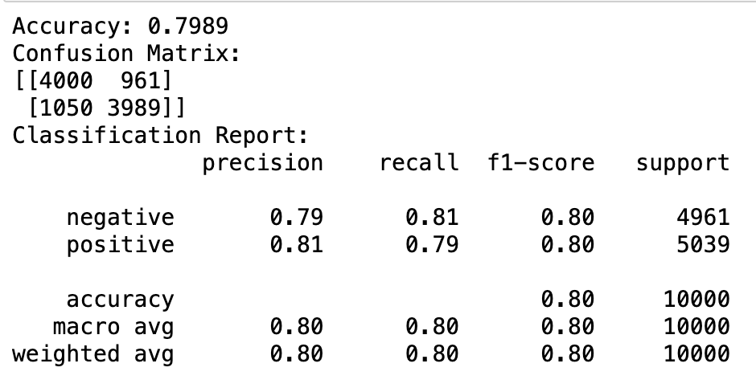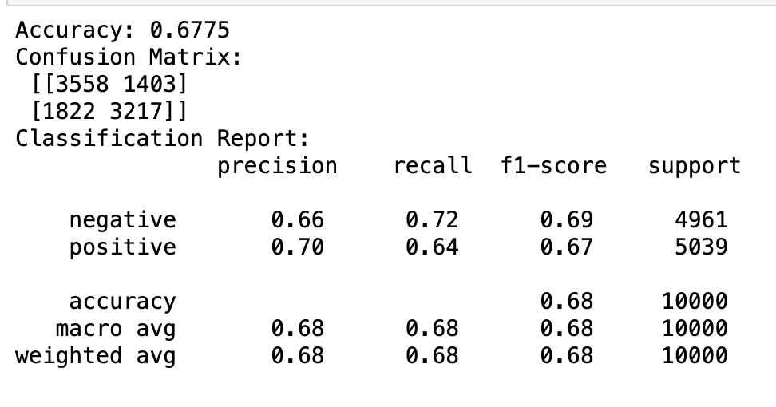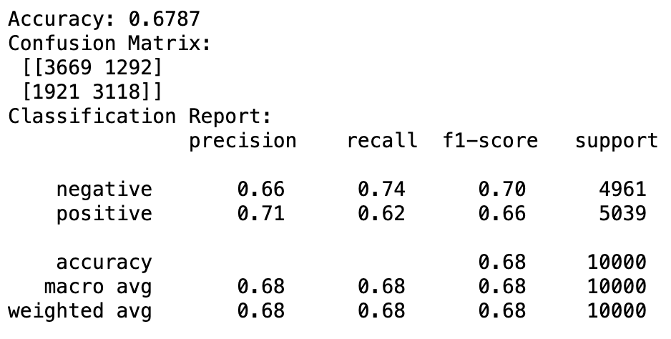

**Performance comparison table**

|  |  |  |  |  |  |  |  |
| --- | --- | --- | --- | --- | --- | --- | --- |
| **Model** | **Accuracy** | **Precision (positive)** | **Recall (positive)** | **F1-Score (positive)** | **Precision (negative)** | **Recall (negative)** | **F1-Score (negative)** |
| TF-IDF + GaussianNB | 0.7989 | 0.81 | 0.79 | 0.80 | 0.79 | 0.81 | 0.80 |
| Word2Vec (CBoW) + GaussianNB | 0.6775 | 0.70 | 0.64 | 0.67 | 0.66 | 0.72 | 0.69 |
| Glove + GaussianNB | 0.6787 | 0.71 | 0.62 | 0.66 | 0.66 | 0.74 | 0.70 |

1. TF-IDF with Gaussian Naive Bayes achieved balanced performance for both positive and negative classes.
2. Word2Vec (CBoW) with Gaussian Naive Bayes exhibited lower performance for both classes compared to TF-IDF.
3. Glove with Gaussian Naive Bayes showed performance similar to Word2Vec (CBoW), with comparable metrics for both classes.
4. TF-IDF with Gaussian Naive Bayes remains the top-performing model, maintaining a balance between positive and negative class metrics.
5. Word2Vec (CBoW) and Glove with Gaussian Naive Bayes have similar performance, but TF-IDF outperforms them in most metrics.